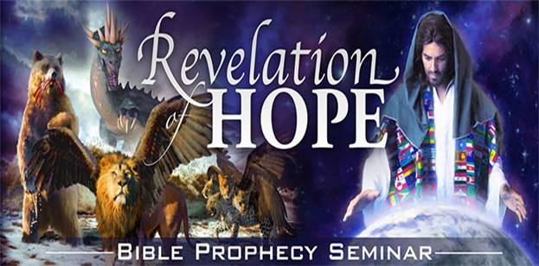

**Do YOU understand the book of REVELATION?**

Broadcasting ……soon….

“Revelation’s Eternal Sign in Earth’s Last Conflict”

This is a message for all of us.

It’s not a message of one religious group or another.

It’s not a message of one denomination or another.

It is GOD’s final call to all of HIS people.

It is a call to worship the Creator.

How do we worship the Creator of heaven and earth?

How does HE remind us of HIS creative power?

At creation did HE leave us a symbol of HIS creative authority?

This is a series of BROADCASTS - on the book of REVELATION.

29 broadcasts in total - which you will receive twice per week - every Monday and Friday evening.

Send your cell number FROM your phone, or add your name and cell number in the comments section below.

IMPORTANT important – very important…

Remember to add your country dialing code please.

You will receive the broadcast individually; you will not be part of a group. There will be NO group disturbances.

Begins this Monday evening…hurry…

Gideon Pelser – Revelation of Hope + 27 82 444 8189

The Cell Phone - No walls – no borders – no limits.

An AWR360/TMI Global Cellphone Ministries Initiative - that you can rely on.

**Notes**

Do not add a date that the series begins.

Remember to change your Facebook setting to PUBLIC before placing adverts on Facebook. Then change it back to friends thereafter.

Be creative and design different adverts every week to attract new participants.

Gideon Pelser

**+ 27 82 444 8189**

Primary Email - [gideon@awr.org](mailto:gideon@awr.org)

Secondary - [gideonpelser@gmail.com](mailto:gideonpelser@gmail.com)

**The Cell Phone - No walls – no borders – no limits.**

**An AWR360/TMI Global Cellphone Ministries Initiative - that you can rely on.**