CHM Leadership Certification
Level III, Course #9
Teens and Religion
Linda Mei Lin Koh, GC Children’s Ministries
(Handouts)

Why Do We Need to Understand Teens? (Barna)
- Teens largely define the values and leisure endeavors of the nation.
- The economy is substantially shaped by their choices as consumers and their work habits in the work force.
- The nature of the family depends on how teens prioritize family and approach parenting
- The future of the Church will be determined by their faith commitments.

Samuel Pfromm Netto, Psychology of Adolescence, 307.
“Adolescence is an age where the individual is concerned with what is spiritual and sacred.”
Religious Needs of Teens
- They need to have a good relationship with religious authorities, such as parents and teachers so that they can see in them coherence between what they live and what they preach.
- They need to have correct concepts regarding religion at this time on their own so that they opt for the faith in Jesus.

Myths about Teens and Religion
- Many think teenager do not like/are not even interested in religion.
- Studies have shown that “adolescence is an age where the individual is concerned with what is spiritual and sacred.”
- It’s true that this phase of teenage life produces radical transformations not only in the form of confronting the relationship with God, but with all aspects of their life.
- The individual is no longer a child, so that by himself, he may discover manner and forms of living and religion that was taught to him.

Teenage is the Best Phase of Life for Religion
- Religious concepts gain more precision and depth in the final years of childhood and during puberty.
- It is the best phase of life to strengthen the values of religion and a relationship with God.

What is the Teenager’s Response?
- It is because that through their nature the adolescent is a reformer of the world and religion does not escape their criticism. (45)
- The problems that they have with religion are not because of religion itself, but because of poor models of parents and religious leaders.
- They want a more authentic religion of reflection, with less routine, and more awareness.” (46)

Key Factors in Teens’ Response
- Positive response to religion depends on the role models exhibited by parents and the individuals who affect the religious life of the child and the adolescent.” (317)
- The rebelliousness of the teen toward religion is a form of rebelling against the people who desire to impose upon them religion which they themselves many times do not practice.

Religious paradox for the teen
- He wants religion. He is concerned with spiritual matters. He desires the security that religion gives to the human being but
- He rejects it, distances himself from it, becomes critical, hard and inflexible because of what he sees and lives within it.

What separates the teen from religion?

Roger Dudley, a North American educator, states that there are three things that lead the teen to abandon the church.

1. The quality of the interpersonal relationships between teens and those who exercise religious authority over them (parents and teachers).
2. Inconsistency between what is professed as belief and what is lived.
3. Concepts that teens have regarding religion.

What separates the teen from religion?
Roger Dudley, a North American educator, states that there are three things that lead the teen to abandon the church:

1. The quality of the interpersonal relationships between teens and those who exercise religious authority over them (parents and teachers).
2. Inconsistency between what is professed as belief and what is lived.
3. Concepts that teens have regarding religion.

Religion, Identify and Independence

One of the most important tasks of adolescence is obtaining independence, emotional as well as economic. This implies reaching a sense of identity. One key question for the teen is: “Who am I?...”
- When the young teen establishes differences between himself and his parents, he can reach the point of not accepting some values and customs adopted by them, as a means of seeing himself as a person with his own identity.

If parents or other authority figures understand the necessity and the nature o f the process of emancipation, they can really help with intelligent and understanding guidance. But if they fight against the process, trying to impose their value system on the teen, not allowing him to obtain a separate identity, the result can be: Rejection of religion.

Are Teens Really Rejecting Religion?
- Teens are not directly against religion, but against the authority which sustains religion.
- Such rebellion is the personal method of the young person to free himself from the restrictions that hinder him from obtaining a separate personality.
- Therefore, the more rigid and authoritarian that the form of applying religious authority be, especially when it is combined with severity and impatience, the more the teen will reject religion.

The National Study of Youth and Religion
- Religious Participation
- Teens are relatively actively in religious organizations and activities.
- Teens attend Sunday school, church, or youth groups, pray and study the Bible.

The National Study of Youth and Religion
2. Theological Beliefs
- Teens are like to hold many traditional Christian religious beliefs.
- Majority of teens believe in God, afterlife, angels, miracles, demons, judgment.

The National Study of Youth and Religion
3. Christian Religions Beliefs
- Teens from conservative denominations more likely than mainline teens to hold these religious beliefs.

The National Study of Youth and Religion
4. Importance of Faith
- Majority of teens report that their religious faith is very important in their lives.
- Most of them have shared their faith with someone not of their faith & have had great worship experience.

The National Study of Youth and Religion
5. Evaluation of Churches
- Majority of teens express relatively positive views of their churches and fellow church members.
- They would continue going to church if given the choice & that their church is warm & welcoming.
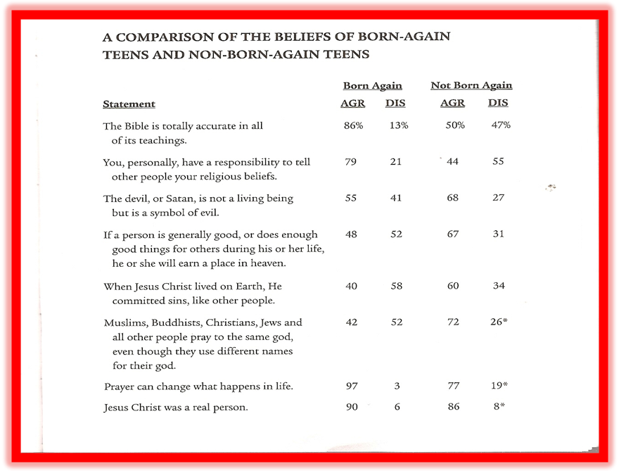

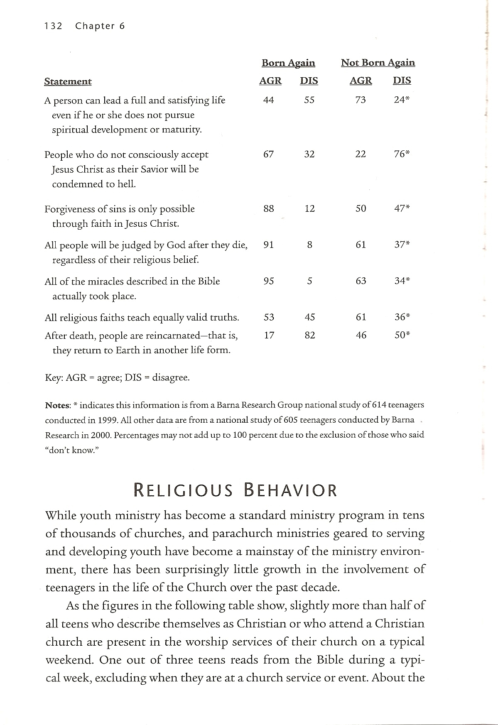
What Makes a Church Appealing?
- People are friendly & care about each other
- A Community with genuine relationships, supportive & family- oriented
- High quality teaching & preaching
- Theological beliefs and doctrine of the church
- Quality of programs and classes for children
- The church being involved in helping poor and disadvantaged people

Barna’s Advice for Youth Leaders
- Understand the world of the teenager—the cultural context of the young person. Read their magazines, watch their TV shows talk to them…
- Enter with a Worldview—integrate your faith into their practical life. Teens are impacted by your modeling.
- Enter with a philosophy & clear vision of why you are engaged in youth work.
- Pray daily for the development of teens.
- Find resources that help you to be effective.

George Barna’s Advice for Parents
- Searching for Meaning – most teens go through a search for significance, seeking to discern meaning, purpose and truth in life. Parents should not force a worldview or philosophy of life upon young individuals, but they can provide key insights and connections that will help them see life from a different vantage point. Ask questions, clarify with them and encourage.
- Define Appropriate Values – Parents who live in accordance with a consistent and Christian value set have a much greater chance of seeing those values absorbed by their children and teens than do parents who leave it to chance and hope for the best. Discussing these choices is only one element in the process; demonstrating what they look like, in practice, is the most powerful influence.
- Family Connection – Most teens want to feel as if they are part of a family that knows them, loves them and will look out for them. Parents must provide focused leadership to family members; have a vision for what kind of family they want to have and the strategies it will take to facilitate such a family experience. Make a commitment to the sacrifices it will take to achieve this vision.
- Faith Connection – The keys to successfully passing on faith from one generation to another relate to making faith central to one’s existence, avoiding lifestyle hypocrisy and integrating faith behaviors and values into everything the family does as a unit and as individuals.

Conclusion
- The teen is open to religion. He/she is vulnerable. He/she is an inquirer, he does not accept everything that he is told, he wants proof, he wants to see, but he is receptive. It is a great phase of life. A great opportunity to make a vulnerable decision for Jesus.
- Satan has taken advantage of this phase to destroy the life of God’s children.
- The Church has slept while the hungry wolf takes its children.
What Can Be Done?
- A specific ministry to work with teens. We cannot waste this phase. If we maintain them in Christ at this age, the possibilities that they will remain in Him for their entire life is very great.
- Tomorrow can be too late!

References
- George Barna, Real Teens (Ventura, CA: Regal Books, 2001)
- Philip Schwadel & Christian Smith, “Portraits of Protestant Teens: A Report on Teenagers in Major U.S. Denominations (Chapel Hill, NC: National Study of Youth and Religion (NSYR), 2005.)
- Roger Dudley, Why Teenagers Reject Religion and What to Do About It (Hagerstown, MD: Review and Herald Publishing Association, 1978).
- Roger Dudley, The Complex Religion of Teens (Hagerstown, MD: Review and Herald Publishing Association, 2007).
- Samuel Pfromm Netto, Psychology of Adolescence (Sao Paulo: Pioneira, Brasilia, INL, 1976.

